Packages and Encapsulation in Java
Packages in Java
🔹 What is a Package?
A package in Java is a namespace that groups related classes, interfaces, and sub-packages together.
It’s similar to folders on your computer that organize files — packages organize code.
It helps in:
- Avoiding name conflicts
- Reusing classes
- Providing access control
- Making project management easier

🔹 Types of Packages
Type | Description | Example
Built-in packages | Provided by Java API | java.util, java.io, java.sql
User-defined packages | Created by developers | com.starx.webapp.utils

Example of Build-in Package:
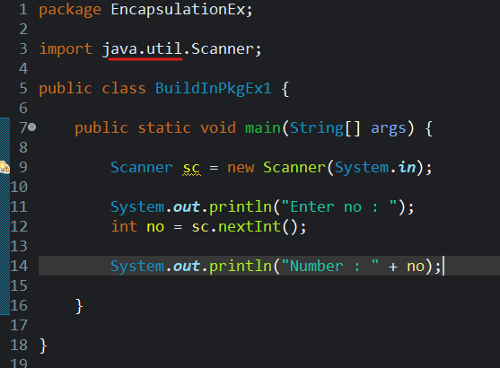

Example of User Defined Package :
Create a package named as “UtilsEx” in your src folder of your project and in that package create a new class named as “LoggedEx”. As shown below :
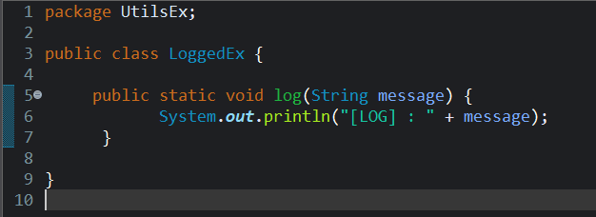
Create one more package named as “EncapsulationEx” in your src folder of your project and in that package create a new class named as “UserDefinedEx”. As shown below :
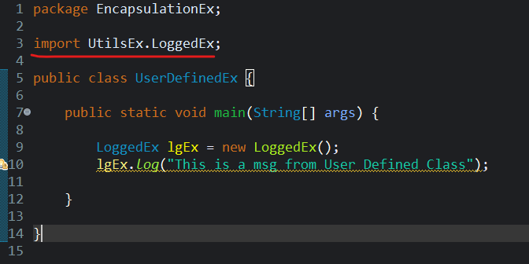
Industrial-Level Example (Demonstration)
Scenario: Website Backend Structure
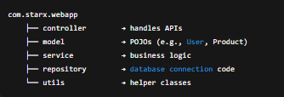

Encapsulation in Java
🔹 Definition
Encapsulation is the process of wrapping data (variables) and methods (functions) into a single unit — a class.
It also restricts direct access to the internal data and provides controlled access through getter/setter methods.
Think: Protecting sensitive data inside a class and only exposing what’s necessary.

🔹 Why Use Encapsulation?
- Ensures data security (fields can’t be directly modified)
- Increases code maintainability
- Allows validation before setting data
- Makes the system modular and flexible

Encapsulation is a process in which we wrap or bind all the data together in a single unit(class or package).
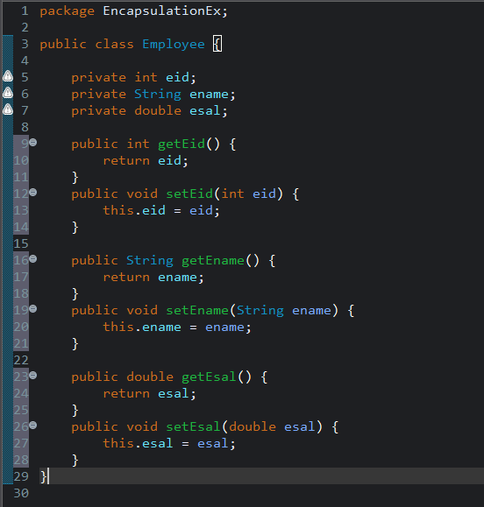
🔹 Syntax Example

Rules to achieve encapsulation:
- Field should be private
- To access thole filed we will be creating public methods (getter and setter)
- Access those field from another class by using getter and setter methods
Getter method is used to get data from a field
Setter method is used to set data into a field

Accessing Employee class into another class. As shown below:
